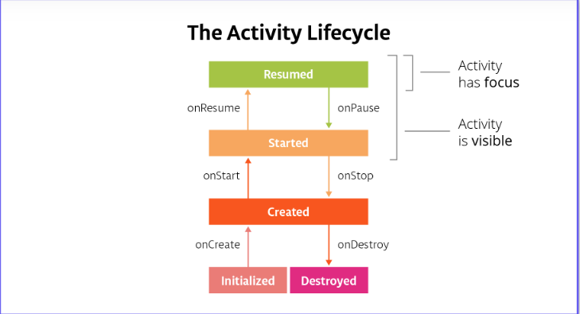

General Definitions
Visible Lifecycle: The part of the Lifecycle between onStart and onStop when the Activity is visible.
Focus: An Activity is said to have focus when it's the activity the user can interact with.
Foreground: When the activity is on screen.
Background: When the activity is fully off screen, it is considered in the background.

Lifecycle States
These are the same for both the Fragment Lifecycle and the Activity Lifecycle.
Initialized: This is the starting state whenever you make a new activity. This is a transient state -- it immediately goes to Created.
Created: Activity has just been created, but it’s not visible and it doesn’t have focus (you’re not able to interact with it).
Started: Activity is visible but doesn’t have focus.
Resumed: The state of the activity when it is running. It’s visible and has focus.
Destroyed: Activity is destroyed. It can be ejected from memory at any point and should not be referenced or interacted with.

Activity Lifecycle Callbacks

onCreate:This is called the first time the activity starts and is therefore only called once during the lifecycle of the activity. It represents when the activity is created and initialized. The activity is not yet visible and you can't interact with it. You must implement onCreate. In onCreate you should:
- Inflate the activity's UI, whether that's using findViewById or databinding.
- Initialize variables.
- Do any other initialization that only happens once during the activity lifetime.

onStart: This is triggered when the activity is about to become visible. It can be called multiple times as the user navigates away from the activity and then back. Examples of the user "navigating away" are when they go to the home screen, or to a new activity in the app. At this point, the activity is not interactive. Dosen't have focus, In onStart you should:
- Start any sensors, animations or other procedures that need to start when the activity is visible.

onResume: This is triggered when the activity has focus and the user can interact with it. Here you should:
- Start any sensors, animations or other procedures that need to start when the activity has focus (the activity the user is currently interacting with).

onPause: The mirror method to onResume. This method is called as soon as the activity loses focus and the user can't interact with it. An activity can lose focus without fully disappearing from the screen (for example, when a dialog appears that partially obscures the activity). Here you should:
- Stop any sensors, animations or other procedures that should not run when the activity doesn't have focus and is partially obscured.
- Keep execution fast. The next activity is not shown until this completes.

onStop:This is the mirror method to onStart. It is called when you can no longer see the activity. Here you should:
- Stop any sensor, animations or other procedures that should not run when the activity is not on screen.
- You can use this to persist (permanently save) data, which you’ll be learning more about in Lesson 6
- Stop logic that updates the UI. This should not be running when the activity is off-screen; it's a waste of resources.
- There are also restrictions as soon as the app goes into the background, which is when all activities in your app are in the background. We'll talk more about this in Lesson 9.

onDestroy: This is the mirror method to onCreate. It is called once when the activity is fully destroyed. This happens when you navigate back out of the activity (as in press the back button), or manually call finish(). It is your last chance to clean up resources associated with the activity. Here you should:
- Tear down or release any resources that are related to the activity and are not automatically released for you. Forgetting to do this could cause a memory leak! Logic that refers to the activity or attempts to update the UI after the activity has been destroyed could crash the app!

Summary of the Fragment Lifecycle
Fragments also have lifecycle states that they go between. The lifecycle states are the same as the activity states. You’ll notice that in your Android Trivia app, you’re using the onCreateView callback - while the fragment lifecycle states are the same, the callbacks are different.
A deep dive into the fragment lifecycle could be a lesson in itself. Here, we’ll just cover the basics with the summary below:
Important Fragment Callbacks to Implement
onCreate: Similar to the Activity’s onCreate callback. This is when the fragment is created. This will only get called once. Here you should:
- Initialize anything essential for you fragment.
- DO NOT inflate XML, do that in onCreateView, when the system is first drawing the fragment NOT reference the activity, it is still being created. Do this in onActivityCreated.

onCreateView: This is called between onCreate and onActivityCreated. when the system will draw the fragment for the first time when the fragment becomes visible again. You must return a view in this callback if your fragment has a UI. Here you should:
- Create your views by inflating your XML.

onStop: Very similar to Activity’s onStop. This callback is called when the user leaves your fragment. Here you should:
- Save any permanent fragment state (this will be discussed in lesson 6)

Other callbacks

onAttach: When the fragment is first attached to the activity. This is only called once during the lifecycle of the fragment.

onActivityCreated: Called when the activity onCreate method has returned and the activity has been initialized. If the fragment is added to an activity that's already created, this still gets called. It's purpose is to contain any code the requires the activity exists and it is called multiple times during the lifecycle of the fragment. Here you should:
- Execute any code that requires an activity instance

onStart: Called right before the fragment is visible to the user.

onResume: When the activity resumes the fragment. This means the fragment is visible, has focus and is running.

onStop: Called when the Activity’s onStop is called. The fragment no longer has focus.

onDestroyView: Unlike activities, fragment views are destroyed every time they go off screen. This is called after the view is no longer visible.
- Do not refer to views in this callback, since they are destroyed

onDestroy: Called when the Activity’s onDestroy is called.

onDetach: Called when the association between the fragment and the activity is destroyed.

The Android Lifecycle cheat sheet — part I: Single Activities

Part I: Activities

Single Activity — Scenario 1: App is finished and restarted
Triggered by:
- The user presses the Back button, or
- The Activity.finish() method is called
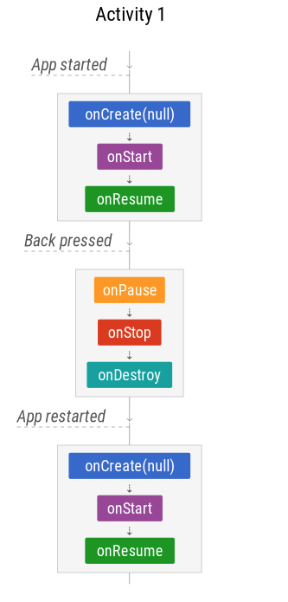
The simplest scenario shows what happens when a single-activity application is started, finished and restarted by the user:

Managing state
- onSaveInstanceState is not called (since the activity is finished, you don’t need to save state)
- onCreate doesn’t have a Bundle when the app is reopened, because the activity was finished and the state doesn’t need to be restored.

Single Activity — Scenario 2: User navigates away
Triggered by:
- The user presses the Home button
- The user switches to another app (via Overview menu, from a notification, accepting a call, etc.)

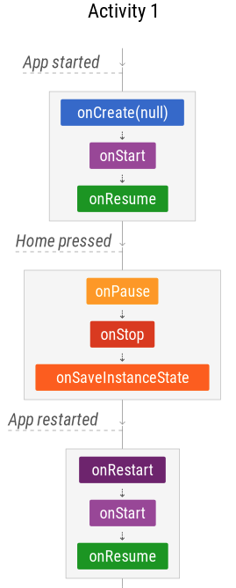
In this scenario the system will stop the activity, but won’t immediately finish it.
Managing state
When your activity enters the Stopped state, the system uses onSaveInstanceState to save the app state in case the system kills the app’s process later on (see below).
Assuming the process isn’t killed, the activity instance is kept resident in memory, retaining all state. When the activity comes back to the foreground, the activity recalls this information. You don’t need to re-initialize components that were created earlier.

Single Activity — Scenario 3: Configuration changes
Triggered by:
- Configuration changes, like a rotation
- User resizes the window in multi-window mode

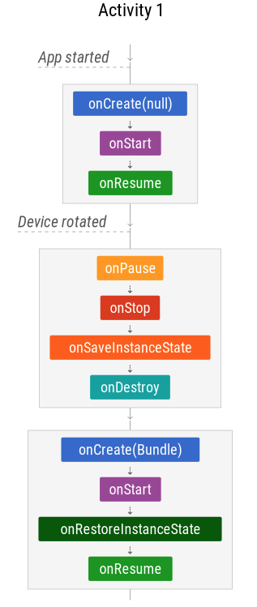
Managing state
Configuration changes like rotation or a window resize should let users continue exactly where they left off.
- The activity is completely destroyed, but the state is saved and restored for the new instance.
- The Bundle in onCreate and onRestoreInstanceState is the same.

Single Activity — Scenario 4: App is paused by the system
Triggered by:
- Enabling Multi-window mode (API 24+) and losing the focus
- Another app partially covers the running app (a purchase dialog, a runtime permission dialog, a third-party login dialog…)
- An intent chooser appears, such as a share dialog

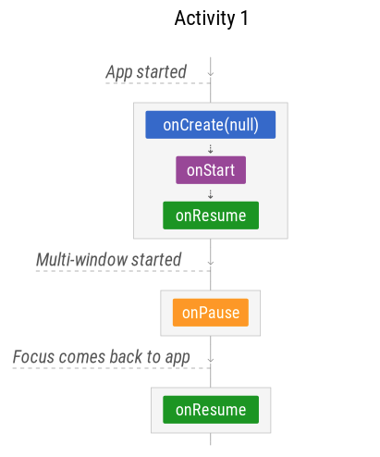
This scenario doesn’tapply to:

- Dialogs in the same app. Showing an AlertDialog or aDialogFragmentwon’t pause the underlying activity.

- Notifications. User receiving a new notification or pulling down the notification bar won’t pause the underlying activity.

The Android Lifecycle cheat sheet — part II: Multiple activities

Back Stack — Scenario 1: Navigating between activities
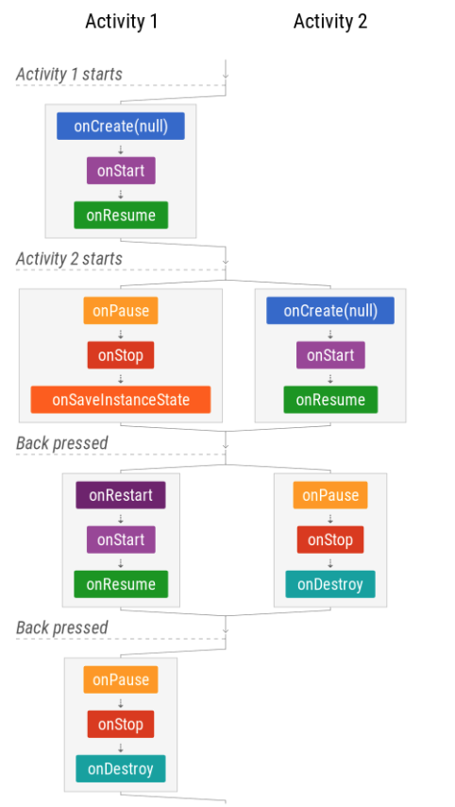
In this scenario, when a new activity is started, activity 1 is STOPPED (but not destroyed), similar to a user navigating away (as if “Home” was pressed).When the Back button is pressed, activity 2 is destroyed and finished.

Managing state
Note that onSaveInstanceState is called, but onRestoreInstanceState is not.If there is a configuration change when the second activity is active, the first activity will be destroyed and recreated only when it’s back in focus. That’s why saving an instance of the state is important.If the system kills the app process to save resources, this is another scenario in which the state needs to be restored.

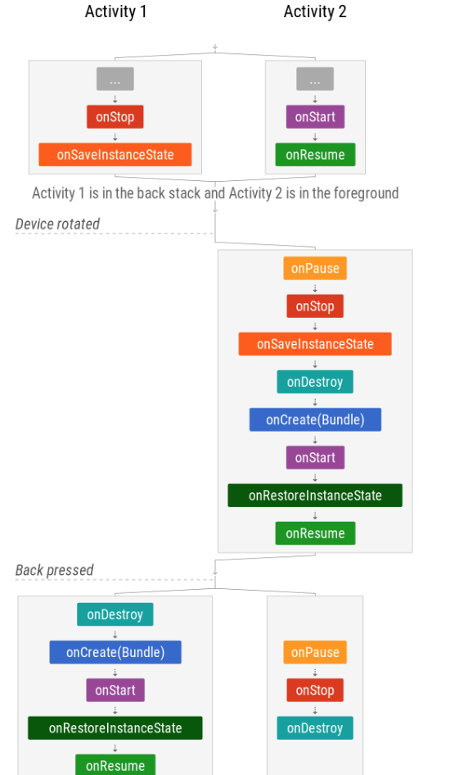
Back Stack — Scenario 2: Activities in the back stack with configuration changes

Managing state
Saving state is not only important for the activity in the foreground. All activities in the stack need to restore state after a configuration change to recreate their UI.
Also, the system can kill your app’s process at almost any time so you should be prepared to restore state in any situation.

Back Stack — Scenario 3: App’s process is killed
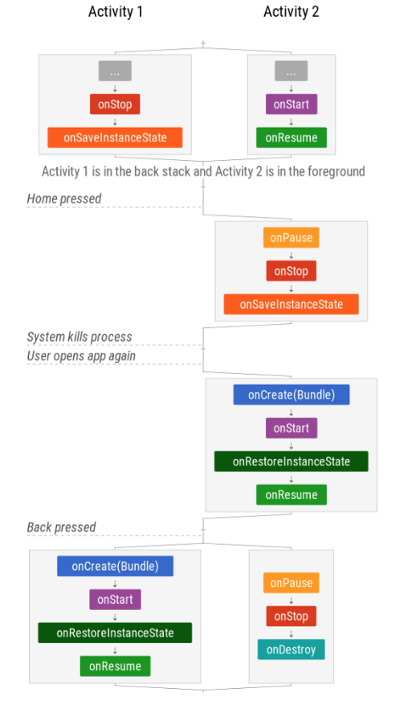
When the Android operating system needs resources, it kills apps in the background.

Managing state
Note that the state of the full back stack is saved but, in order to efficiently use resources, activities are only restored when they are recreated.

The Android Lifecycle cheat sheet — part III : Fragments

Scenario 1: Activity with Fragment starts and finishes
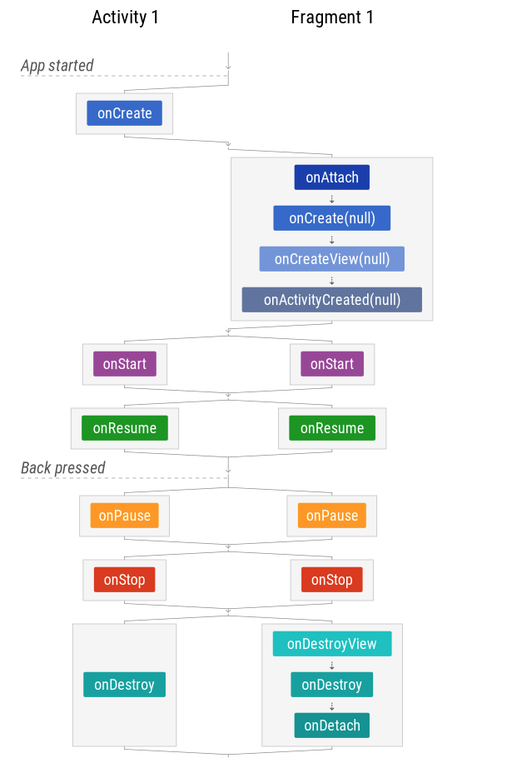
Note that it’s guaranteed that the Activity’s onCreate is executed before the Fragment’s. However, callbacks shown side by side — such as onStart and onResume — are executed in parallel and can therefore be called in either order. For example, the system might execute the Activity’s onStart method before the Fragment’s onStart method, but then execute the Fragment’s onResume method before the Activity’s onResume method.
Be careful to manage the timing of the respective execution sequences so that you avoid race conditions.

Scenario 2: Activity with Fragment is rotated

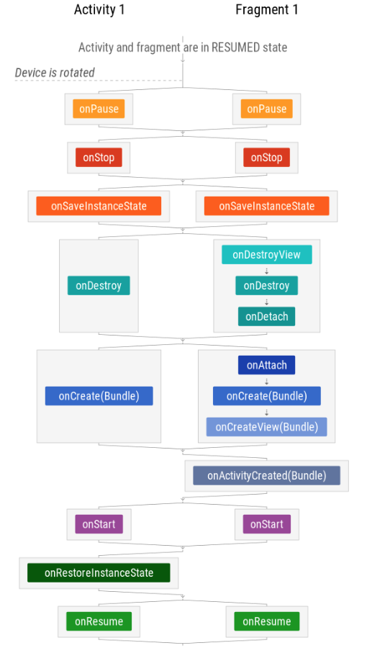
State management
Fragment state is saved and restored in very similar fashion to activity state. The difference is that there’s no onRestoreInstanceState in fragments, but the Bundle is available in the fragment's onCreated, onCreateView and onActivityCreated methods.
Fragments can be retained, which means that the same instance is used on configuration change. As the next scenario shows, this changes the diagram slightly.

Fragments — Scenario 3: Activity with retained Fragment is rotated

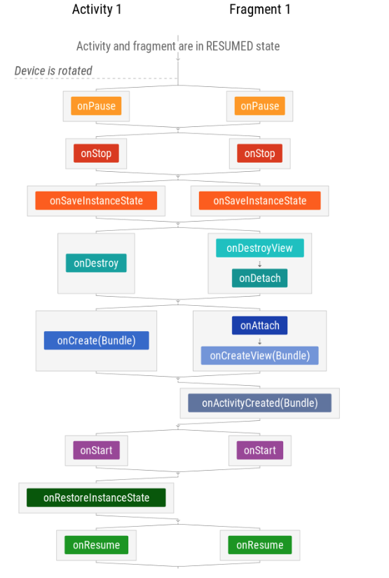
The fragment is not destroyed nor created after the rotation because the same fragment instance is used after the activity is recreated. The state bundle is still available in onActivityCreated.
Using retained fragments is not recommended unless they are used to store data across configuration changes (in a non-UI fragment). This is what the ViewModel class from the Architecture Components library uses internally, but with a simpler API.

The Android Lifecycle cheat sheet — part IV:ViewModels, Translucent Activities and Launch Modes

ViewModels
The lifecycle of ViewModels is quite simple: they have only one callback:onCleared. However, there’s a difference between scoping to an activity or to a fragment:
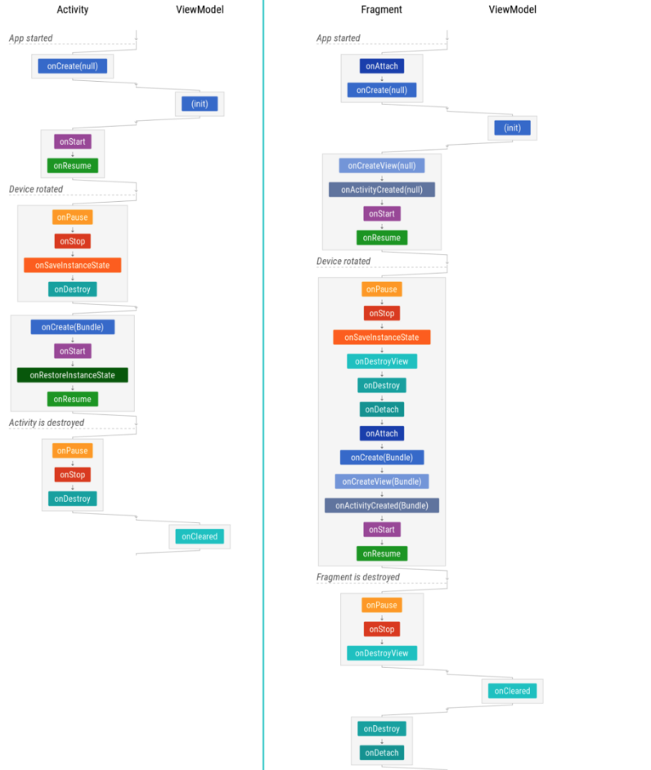

Note that the initialization happens whenever you obtain the ViewModel, which is normally done in onCreate.

Translucent Activities
Translucent activities have translucent (usually transparent) backgrounds so the user can still see what’s underneath.
When the property android:windowIsTranslucent is applied to an activity’s theme, the diagram changes slightly: the background activity is never stopped, only paused, so it can continue receiving UI updates:
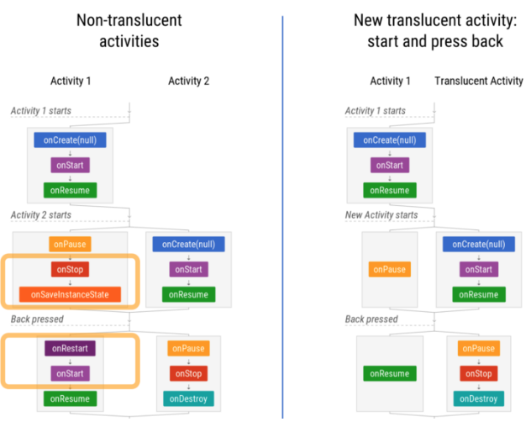

Also, when coming back to a task, both activities are restored and started, and only the translucent is resumed:
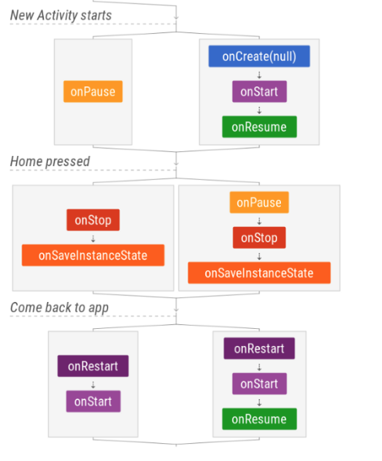

Launch Modes
The recommended way to deal with tasks and the back stack is, basically: don’t — you should adopt the default behavior. For more details, read Ian Lake’s post about this topic: Tasks and Back Stack.
If you really need to use SINGLE_TOP, here’s its diagram:
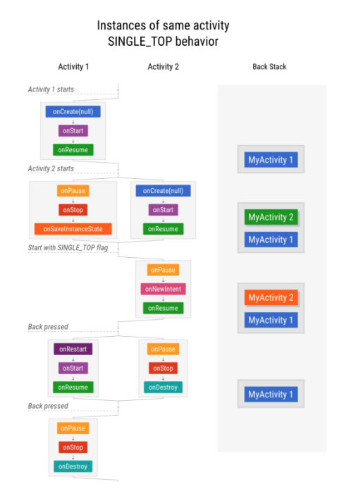
Note: If you use Jetpack’s Navigation Architecture Component, you will benefit from Single Top support and automatic synthetic back stack.

